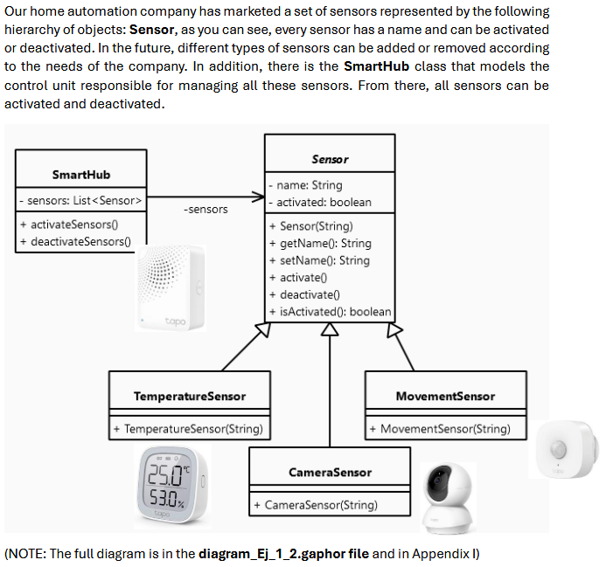

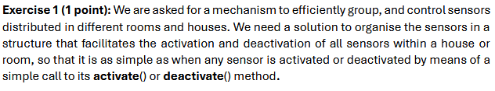COMPOSITE

**TO ORGANISE --> Structural**

**a house or room --> jerarquía pq pq kitchen belongs the house**

**Sometimes switch off the whole house and sometines only a room**

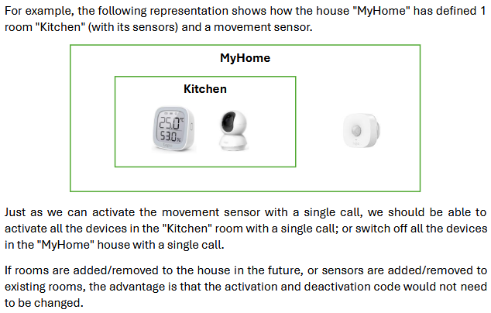

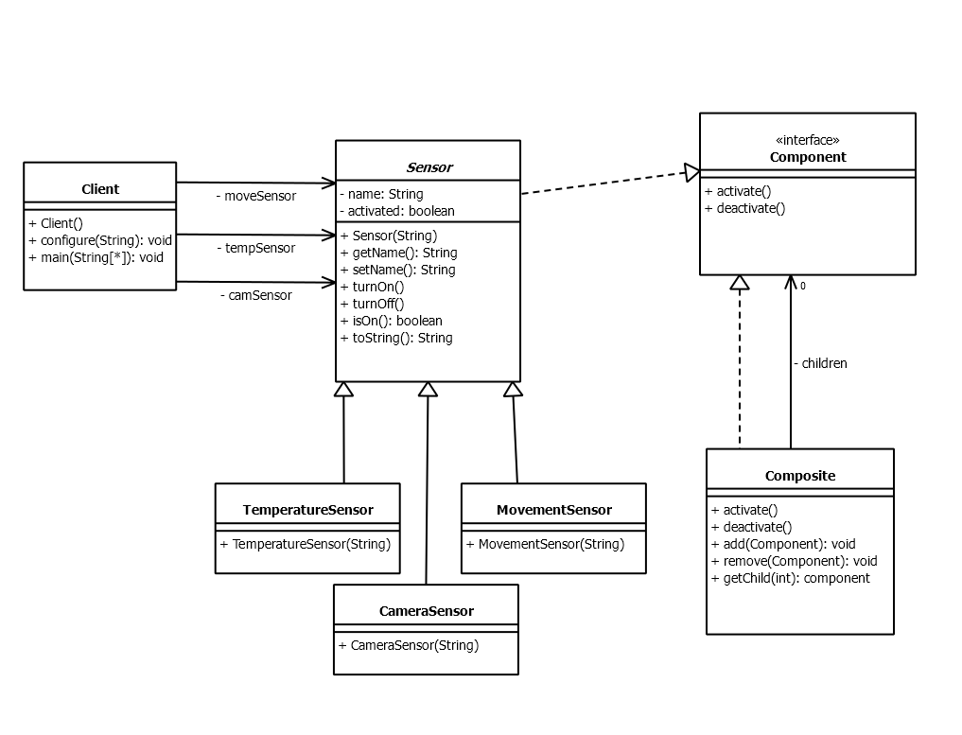

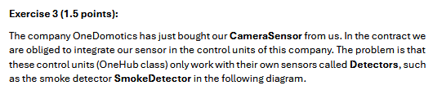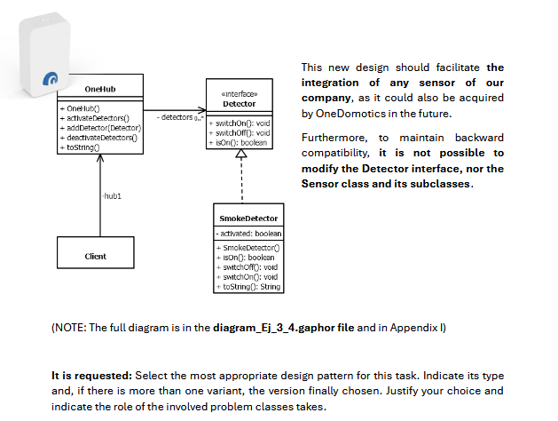

TO indentify that we need an adapter bc we have 2 different devices

Class adapter or object adapter? We need to consider the Sensor and all the Subclasses!!! And we can have mulitple detectors --> hierarchy

We need to adapt the sensor to detector so now oneHub is the main company so we have to adapt the sensor to detector so now everything will be trated as detector